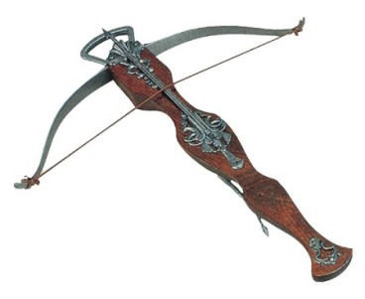
TENSEGRITY - IT'S POTENCY
On my personal website (http://hammer.bas.lv/), I wrote that in my soul I am rather "naturalist" rather than a builder. I am sure that this phrase caused appearence on the face many readers of condescending smile. They probably thought: "We are THE SPECIALISTS, and if he takes up everything, then he can not do anything". I don't protest! Everyone has the right to have his own opinion, if only his opinion is well argumented and he not afraid to protect it at the public. For example, I am not afraid it. I think that even these skeptics, if they find the strength to read my short article to the end will not be smiling.
Yes, I have Diploma of civil engineer for "industrial and civil construction". Someone is biologist, someone is mathematician... But we are living at the WHOLE AND INEXTRICABLY WORLD, so if in one chapter I have raised issue of cable-stayed structures, and in another - the problem of AIDS, personally I am not seeing anything strange in it. We, similar to the builders of the "Babylon's Tower", were divided once on the "groups of like-minded persons" and as wood grouses on a lek, "each sings his own song", often completely unable to hear each other. But in vain. It is time, as the Bible says, "to gather stones". Indeed, it may happen that soon again "will come a big wave" (as it has already happened earlier), and our civilization simply will be washed off the face of the Earth, but we will not have time "to understand and forgive each other". If so that someone must come from outside to establish communication between narrow specialists to help them find, see, understand and forgive each other, it seems me, that I shall be such a person.
Those physicians who flinched by reading the title of my article, I will ask relax. Today I will not bother you. However, this does not mean that the concept of "tensegrity" will leave you alone. I will not go farther, but, in my opinion, term of "tensegrity" also has a direct relationship to the problem of sexual impotence.
All those who studied physics course in the middle school, remember, apparently, this picture: metal ball lies on a flat table. The teacher explains: this ball is in the "neutral equilibrium". The following image is the ball falled to the pit - this ball is in "stable equilibrium". The third ball "climbed to the mountain's summit". Here's such third ball and interest us more than any other. Of course, he is in "not stable equilibrium", but this ball is more interesting for me then others: he CAN do the work, its POTENTIAL energy is much larger than the first two balls. Namely the POTENCY of this ball (and not the potency of a big guy) and entered the title of this article.
What is the "potential energy"? Where did it come from? When, where and why it disappeared? I think that every sane person sometimes asks himself these questions. I also had put myself such questions. And earlier I rised them before myself more often than other people. Now I do not consider them at all. Why? Yes, simply because once something "clicked in my head" and all. After that in my head everything fell into place (as was once with the Buddha). It became easier to live, it became easier to communicate with other people, became easier to forgive...
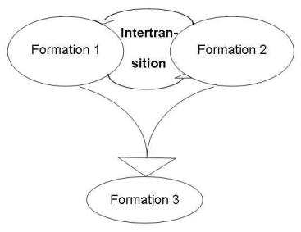
Let's start from the beginning. We have a metal ball ("Formation 1"), is available to us and the planet Earth ("Formation 2"). There is also "some kind of the mutual influence on each other ("Intertransition")". About what kind is this impact and how to shortchange him, I will not spread. To this already "put his life" the great Isaac Newton. I only note that with the mysterious word "intertransitions" let suffer theoretical physicists. Namely they in their works always have some kind of "intertransitions" and "transmutations." For the average person is just INTERACTION. That's all. Look at the diagram below.
Above left - our ball, top right - the planet Earth. If these objects in a space are far from each other, then together they form a "closed tensed system" - "Formation 3". And the interaction between them carry out namely the Earth's gravitational field. Agree: there would be no gravitational field - would not have been "closed and tensed system". The gravitational field is present - closed and tensed system "ball-to-Earth" exists. That's the essence.
Here's how "the tensed unity" of Buckminster Fuller should be understood!
If the reader was not really too lazy to read up to this line, then further for him, I think it will be even more interesting.
In the analysis of the lying below examples the reader should look at the above picture and include a little imagination.
• bended twig + rope + their interaction = Hunting Bow
• mass of water + dam + their interaction = hydropower plant
• man + woman + their interaction = family (or child)
• criminality + law-enforcement system + their interaction = legal balance
• state number one + state number two + their interaction = war (or peace)
This list, as you've probably guessed, I can go on INDEFINITELY, just like and the series of my cable-stayed structures, which has already passed my public presentation (See "«Tensegrity» - a new direction in architecture" in the chapter "Architecture of Space" on my site http://hammer.bas.lv/). For the first four rows in the list above, I think the explanation is not required. If someone does not understand the fifth line of this list, I'll explain it.
In the above the system "ball-Earth" the essence of maintaing them together the interaction between them is viewed quite easily - it's gravity. Counteracts gravity the desk (for our ball) or the centrifugal force (for the planets of the solar system). With the case of two states (as well as with other social and historical formations) the question is much more difficult. In each case, you need to understand specifically what was the content of the interaction, only then we will know to what it lead. These questions deal with the diplomats, whose area of activity - foreign policy. I also gave a list of only the two extreme cases - war or peace.
I think that for many people is already beginning to clear up the meaning given by me on the website of the phrase "...my intellect hold in mind whole the Universe..." (see chapter "Thinking Aloud" in my site). So much the better for them. For lovers of the "pencils and ropes" I want to note: let's think more broadly, my friends. Often loosens up your mind and you will be like Heaviside earlier, to get from your science just a real pleasure.
Due to the above examples the conclusion suggests itself: "the tensed unity" which was was once invented by Buckminster Fuller, this is simply "another writing form" of the first half of the "World Harmony Law", which was once discovered by Makarov. And under the word "tensegrity" I can understand even such kind of potency which is hidden in an ordinary bomb. I believe that readers already understand: the concept of "tensegrity" can be used to describe very many stable systems across the universe.

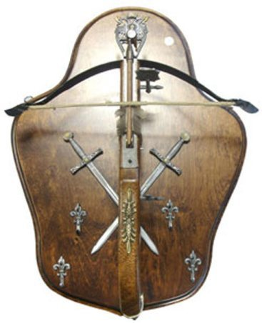
If I were to ever was forced to invent coat of arms (as happened, for example, with Sir Isaac Newton), then I could not on my coat of arms to portray anything other than CHARGED CROSSBOW as the embodiment of symbol of "the tensed unity" of Buckminster Fuller, but which was created , namely, with the human hands. I'm hoping that the reader already deeply feels how huge POTENTIA is hidden in the concept of "tensegrity" in general, and in crossbows, in particular.
If even the will of fate I came "at the intersection of sciences," then I must once and forever to formulate this generalized principle, more exactly: a generalized definition of tensegrity-systems. As a creative person, I reflected in the definition of tensegrity-system not only her birth but her death too. I think that Buckminster Fuller would not refuse to take me as an co-author...

BUCKMINSTER FULLER'S TENSEGRITY-SYSTEM GENERALIZED DEFINITION

Tensegrity-system is a system formed by the union of two or more than two interconnected elements (synthesis). Balance of interaction between the elements provides a system the unity and stability. If the external effects destroy the element from a stable state or remove it, the system is rebuilt and becomes the new formation. If the connections between the elements disappear, the system loses its existance (decay).
I would like to accent reader's attention to two points:
• system may lose the element and to remain stable
• system be destroyed when the number of broken bonds reaches critical level
I assure you: this definition will be clear to representatives of any of the areas of human activity (an architect, a builder, a physicist, biologist, politician, astronomer, historian, ...). Now we can safely continue construction of our "Babylon's Tower".
Note: in case of violation of a stable state of the system its POTENTIAL ENERGY quickly flies out of the system. Then all may occur:
• a jib from a crossbow flies out
• a hydroelectric power plant becomes destructed (see the accident on the Sayan-Shushenskaya power plant)
• a family breaks up (divorce)
• The Soviet Union falls into separate states (my "Marxist-Leninist philosophy")
• a bomb explodes, the fission fragments fly away
In all the above examples, namely POTENTIAL, latent earlier energy, burst out. Since it is the supply of POTENTIAL energy posses each of tensegrity system, so I reflected this fact in the title of this article.
With regard to medicine and biology, each sex offender explains his actions by saying that him was very necessary to "release the energy", which I think is known to each of us.
Notes: picture of the first crossbow copied from the site http://www.vipmir.ru/
picture of the crossbow with stand - from the site http://www.gua.kiev.ua/
03/18/2011 Segrim

Other Makarovs' works you could find on his personal web-site: http://hammer.bas.lv .

